Pivot Table Practice – Google Sheets
Google Sheets pivot tables are a useful tool for manipulating data for analysis. In this example we take raw data and compute a percentage of the total (normalize) then group the data. Start by downloading the data for Teacher Race. Select 5 contiguous years and CSV ouput. Open an new Sheet. Chose File | Import. Upload the file into the Sheet.
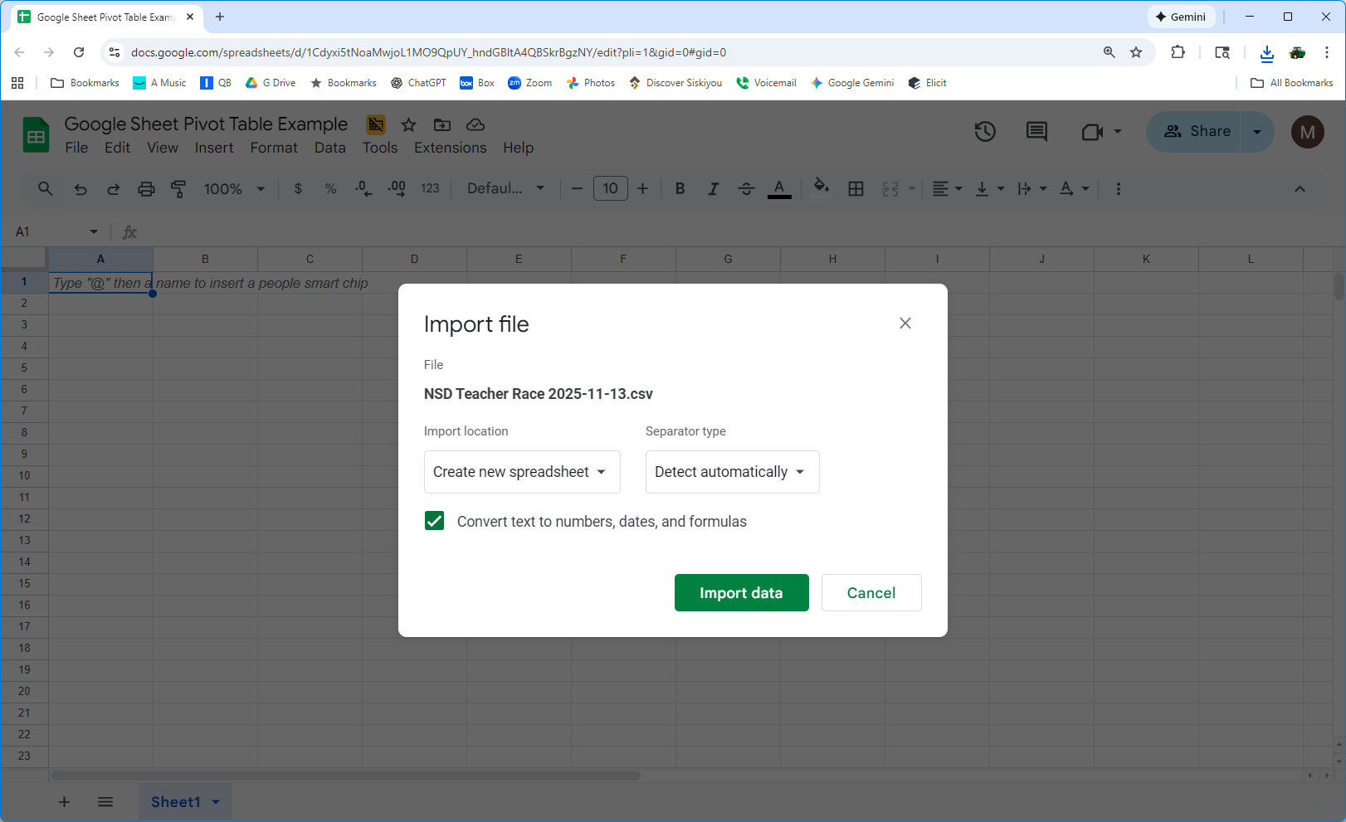

Select the cell in the upper left corner. Choose the Insert menu and select Pivot Table.
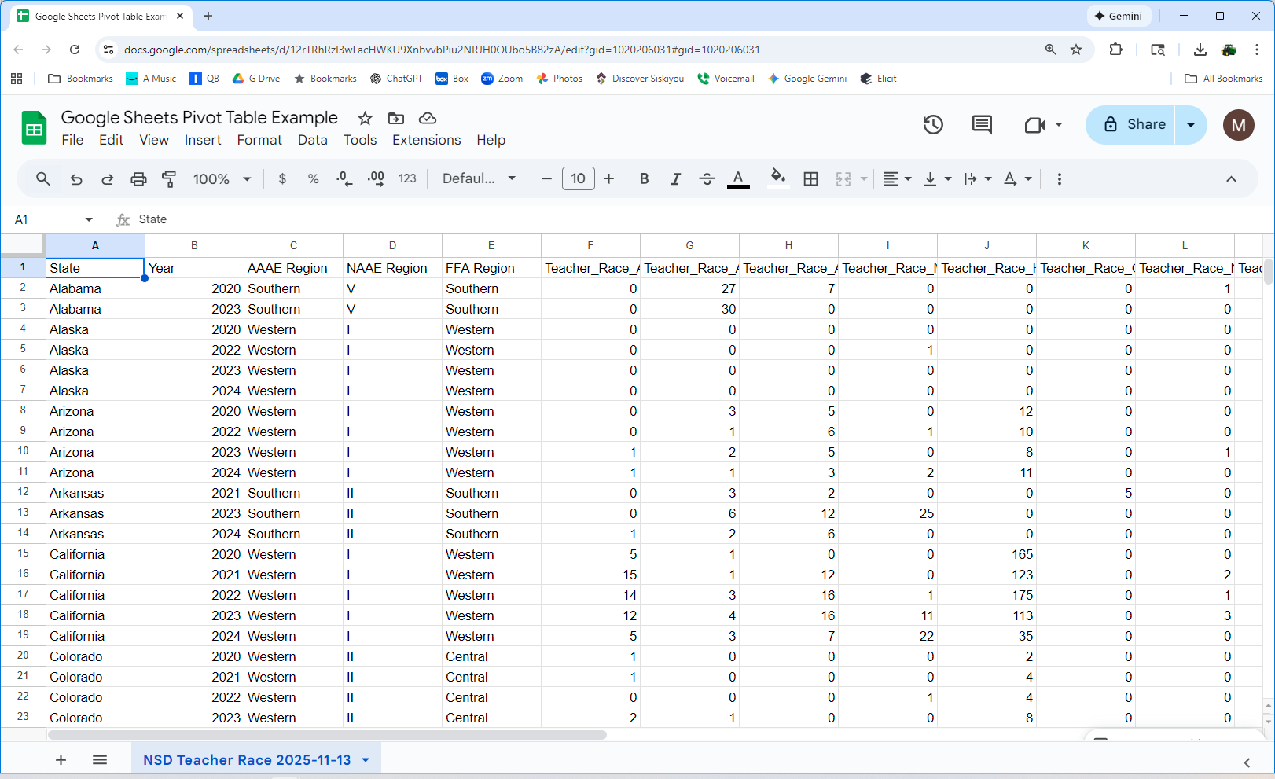
Select the defaults and OK. A new sheet (tab) will be created.
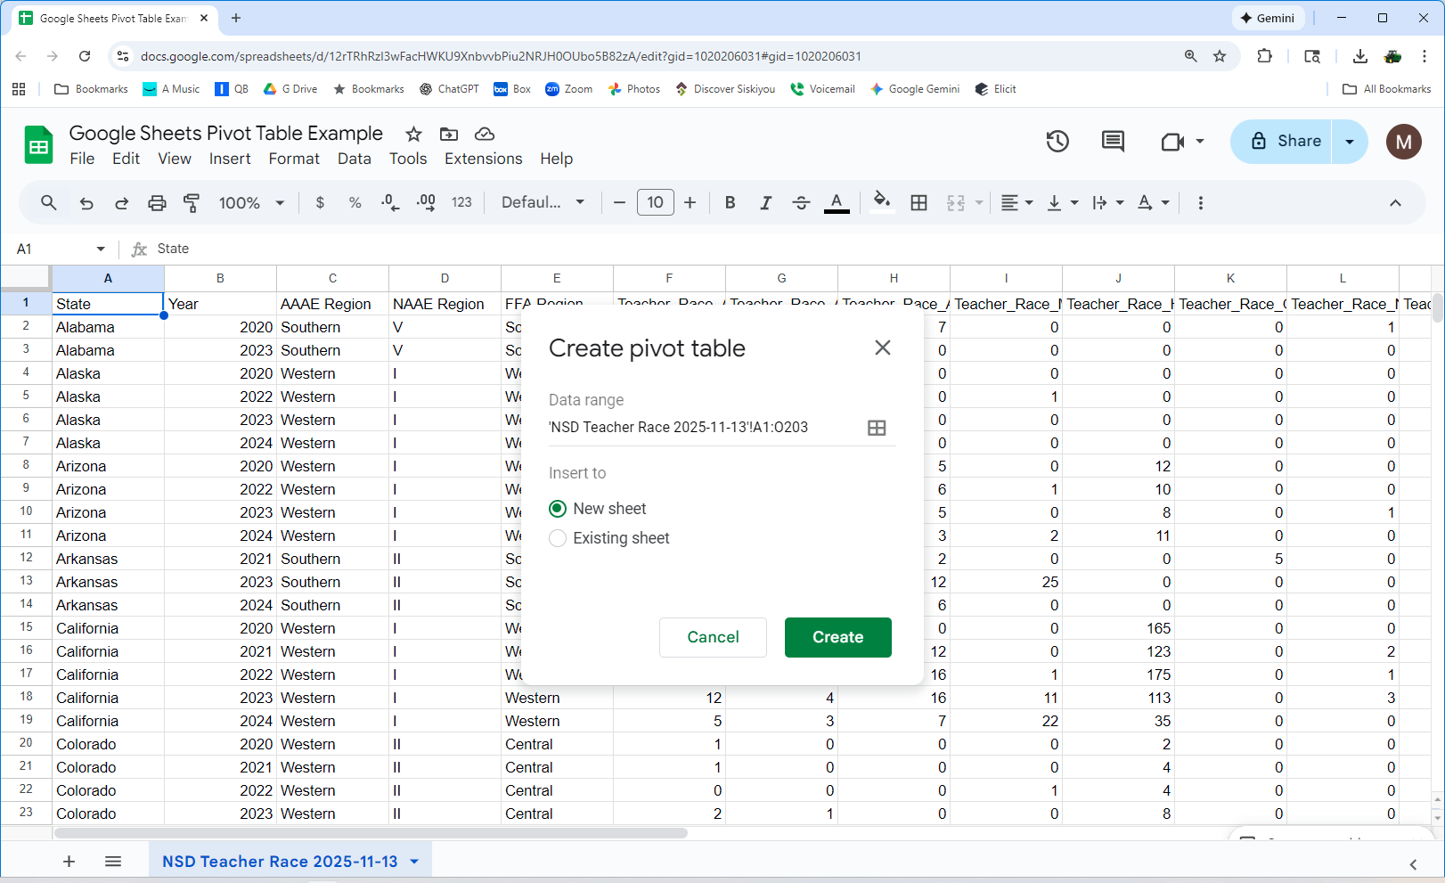The pivot table will be blank until you create some rows and columns.
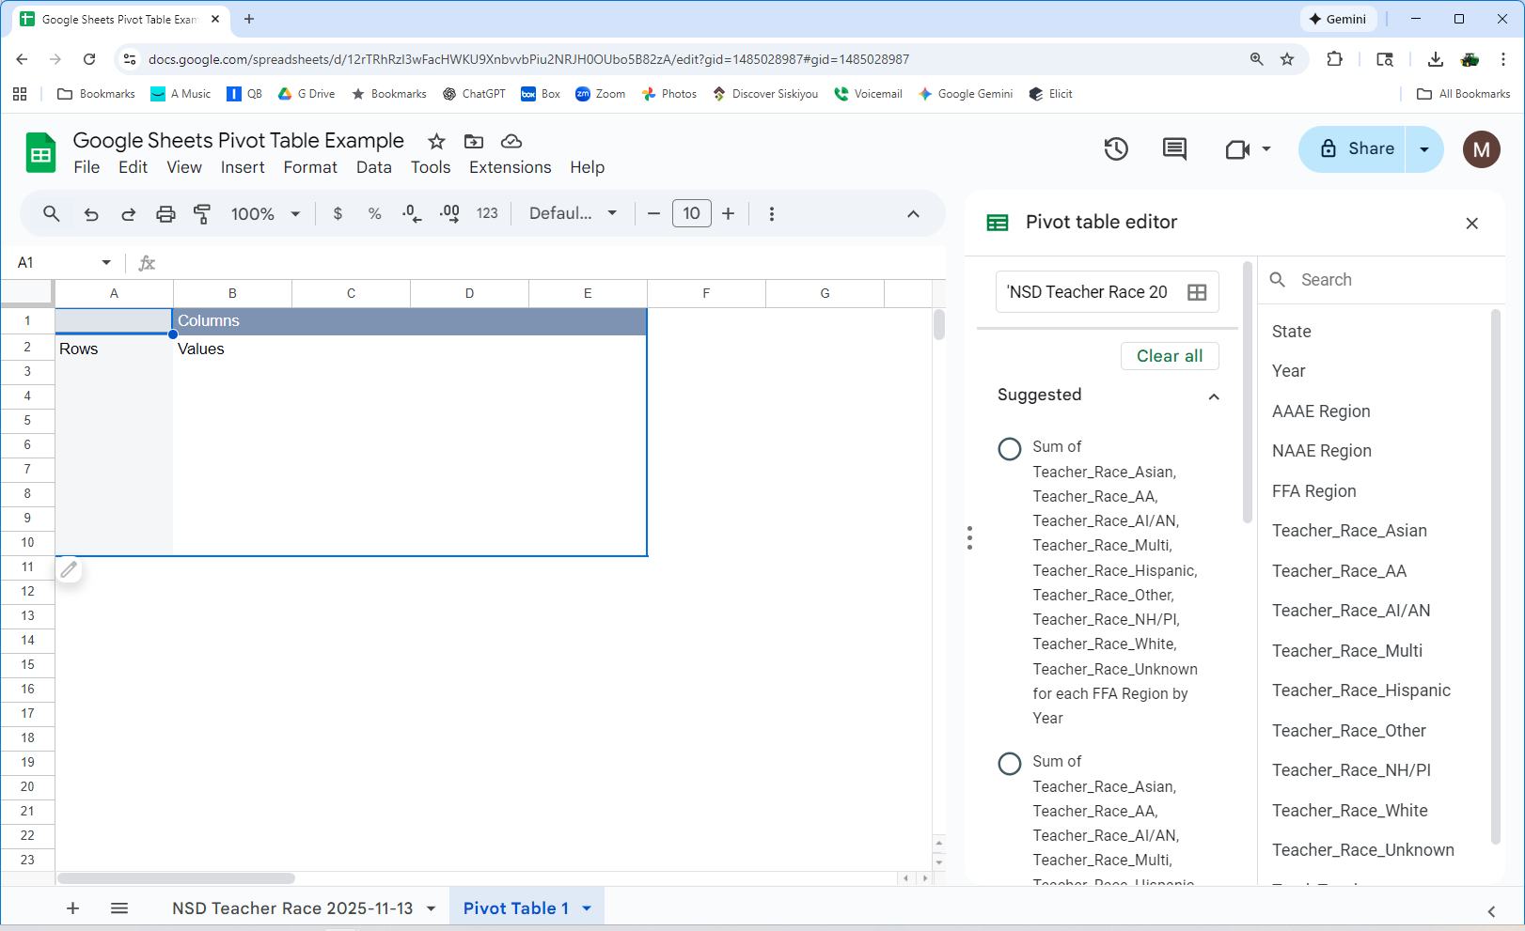
Click on Add Rows and select FFA Region. Click on Add Values and select races (one at a time). Edit the column headings as desired. All 5 years will be added together. To see annual changes add year to the rows.
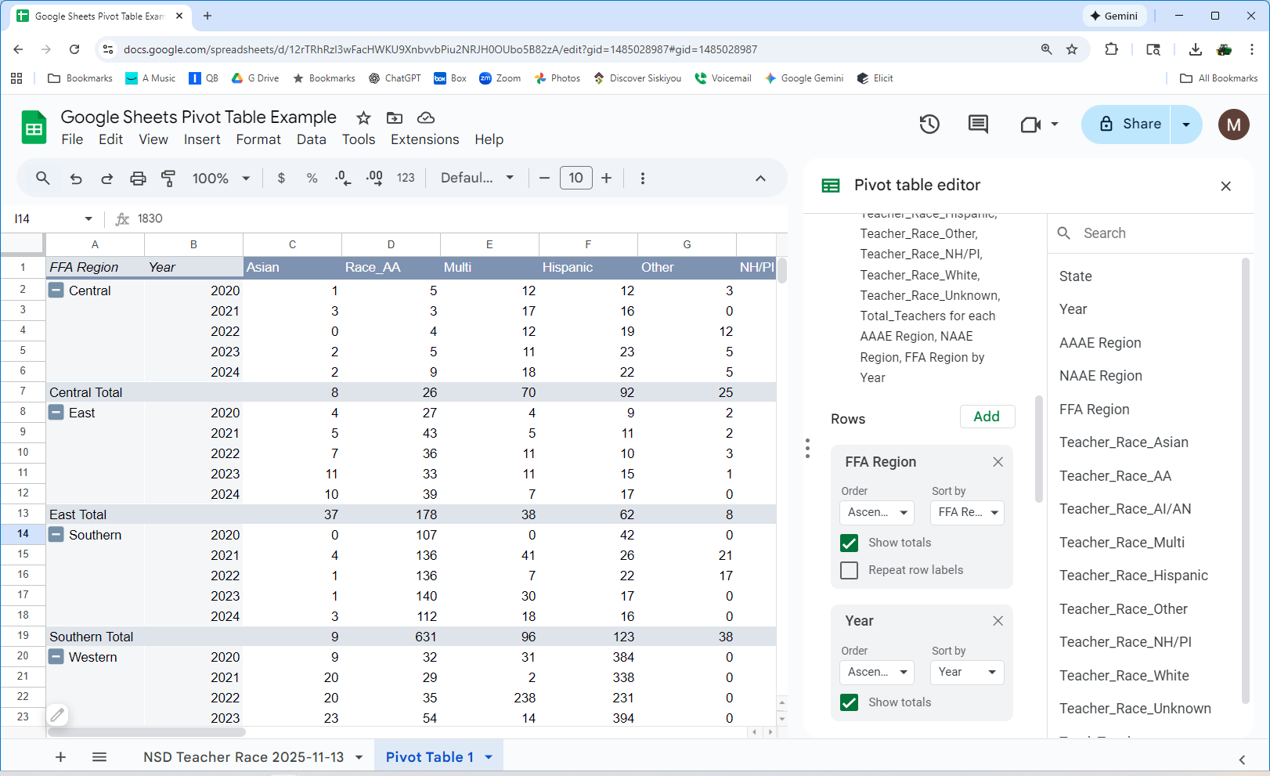
Note that the number of states may vary by year so the total number of teachers may be misleading. To explore which states reported remove all fields (to return to a blank pivot table. Add state to the rows and year to the columns. Add Total_Teachers as a value.
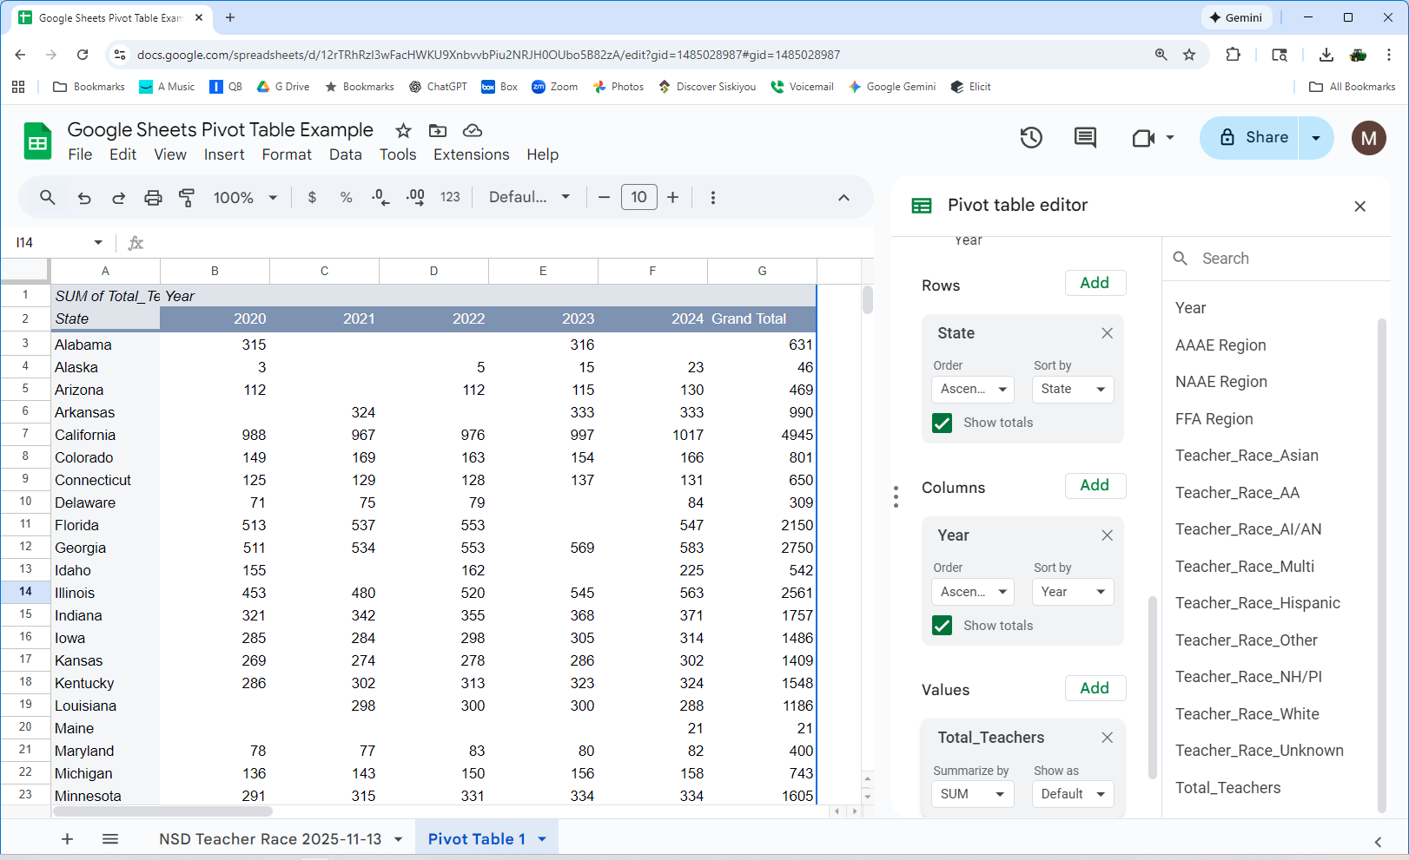
Examine the data. You can see some states did not report every year. To get a better understanding of the data we can convert the raw data to a percentage of total teachers. Remove Total_Teachers as a value. In the Pivot table editor panel, go to the "Values" section. Click "Add" and select "Calculated field". Edit to column name as Hispanic. Enter your formula in the formula box. Use the exact column headers from your source data. Enter =sum(Teacher_Race_Hispanic)/sum(Total_Teachers). Click "Add" in the bottom right corner to create the new calculated field in your pivot table. Select all values and convert to %.
Remove State from the Rows and add FFA Region.
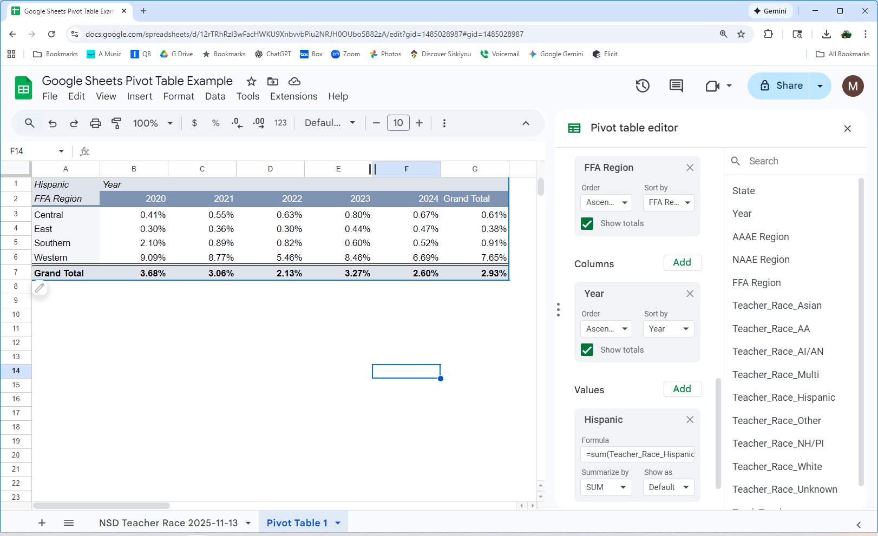
Normalizing the data (show as a percentage of the total) will give you a better sense of the makeup of each region. To do this create “calculated fields”. Select Pivot Table Analyze then “Fields, Items, Sets”. You will be creating calculated columns.
For each race create the calculated field by dividing the race by total teachers (see sample above). The calculated fields will be added to the field list (on right).
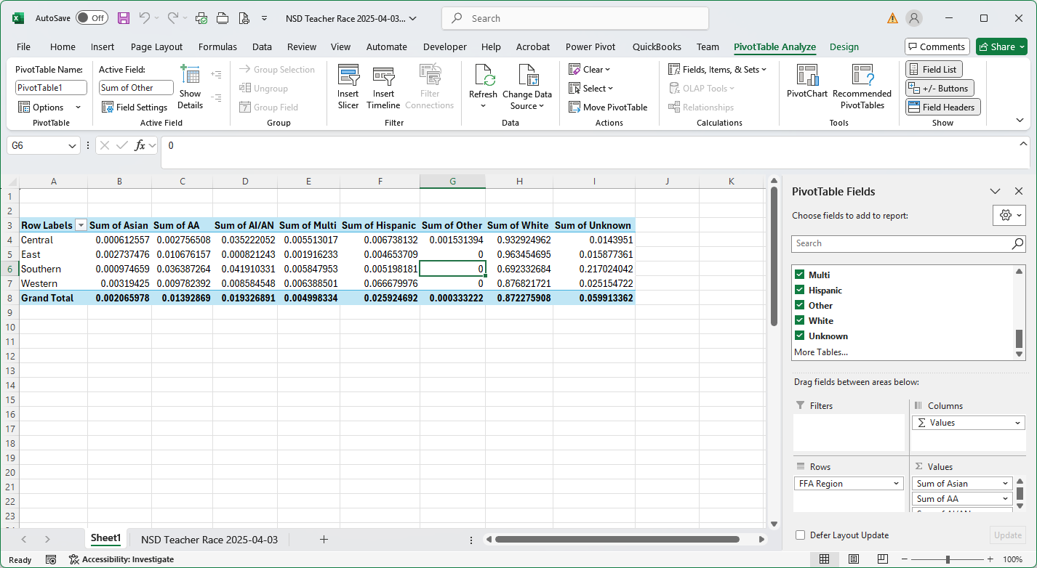
Now select the area with the numbers and format as a percent.
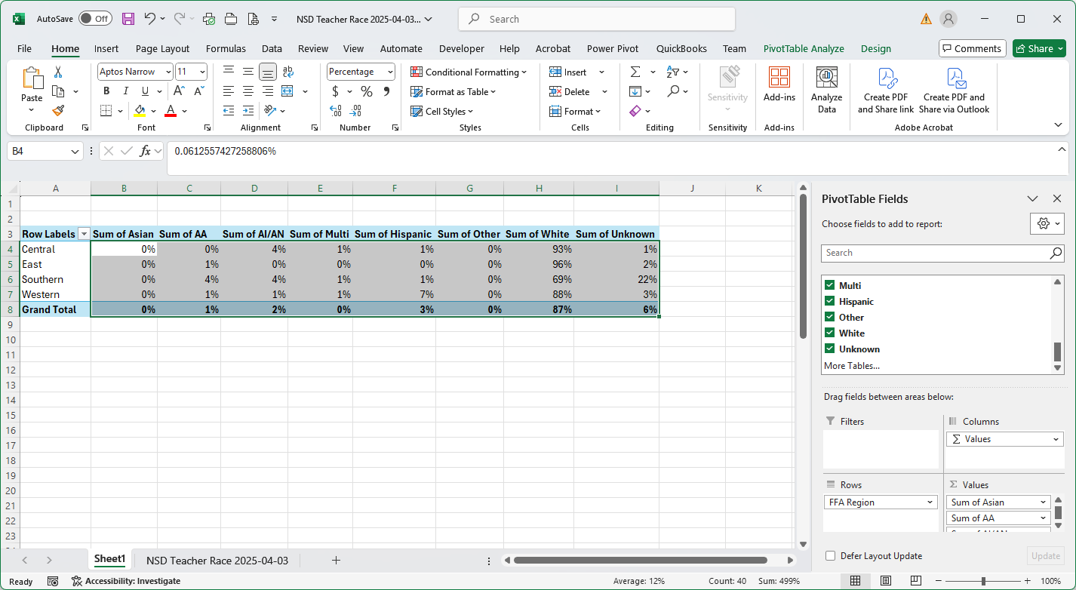
Now you can explore different groupings. Un select FFA Region. You will have a national summary. Drag NAAE Region to the row to summarize by NAAE Region.
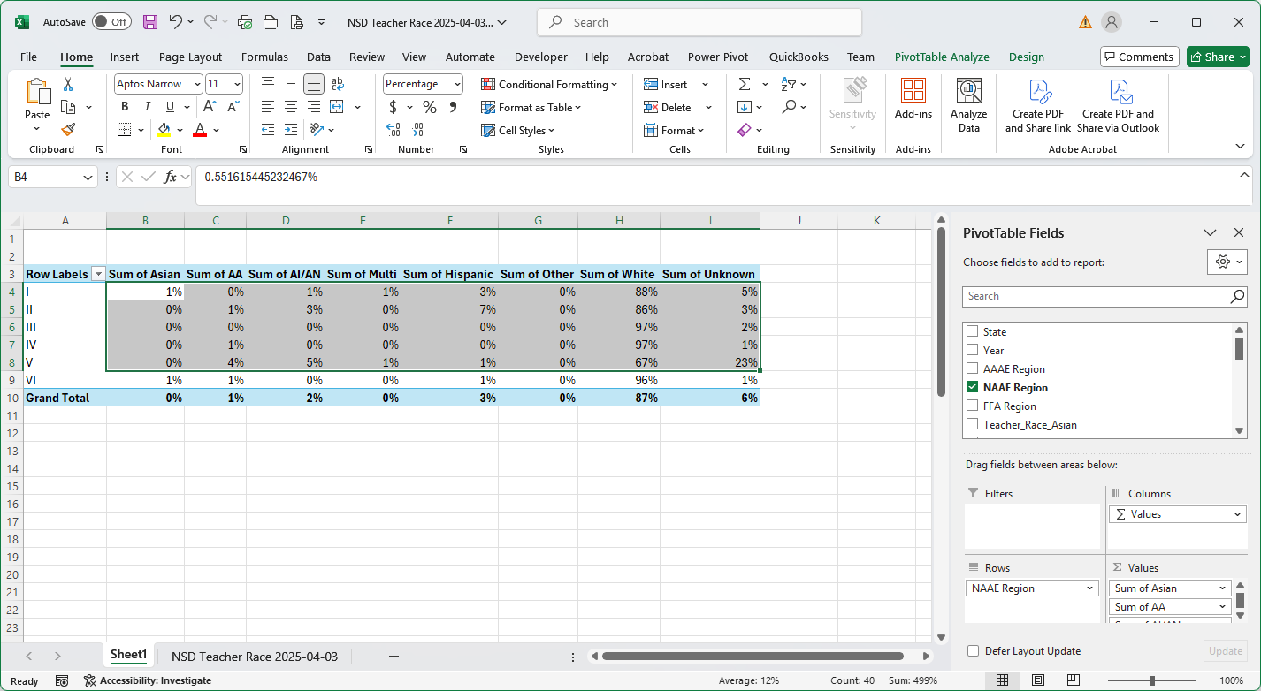
To see state detail drag State below NAAE region in the row box.
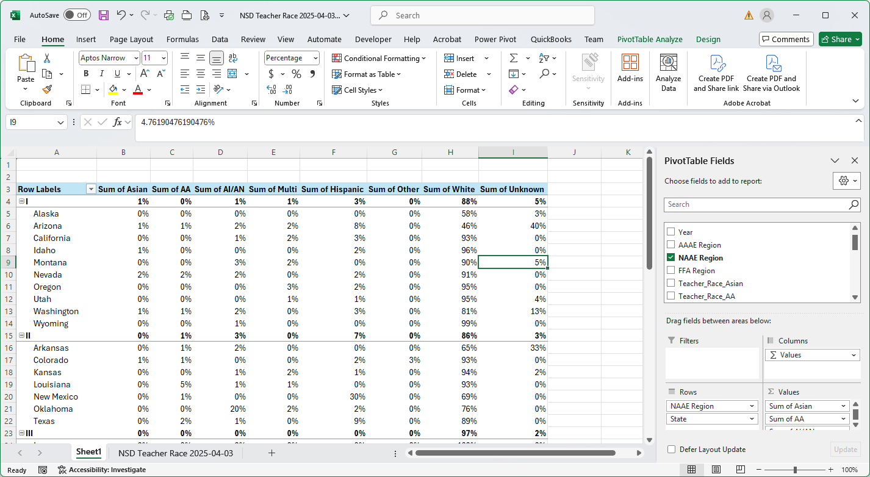
The above day combines all years. To look at trends by region. Un-check state and drag Year below FFA Region.

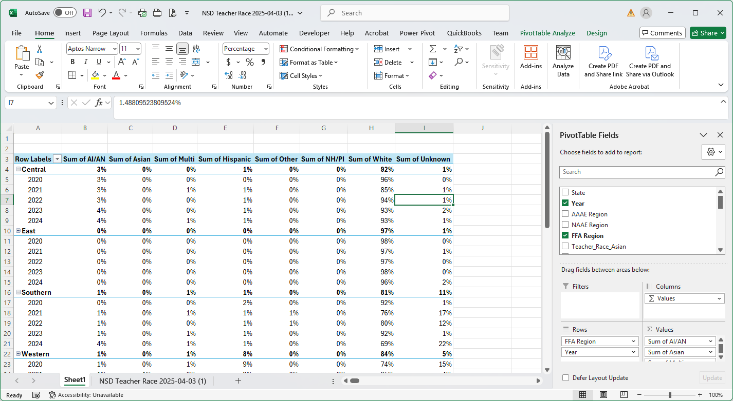
You can further explore the data using filters. Try this by draging year from the row to the filter box.
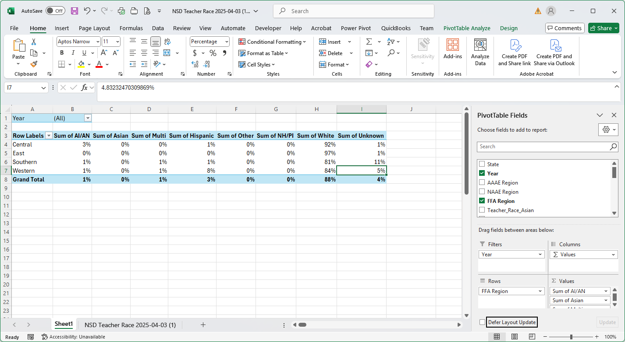
Select the dropdown in cell B1. Select only one year to display the data for the single year.
Sometime you may wish to display your data on a chart (graph). Use the Pivot Chart option (Pivot Table Analyze | Pivot Chart). NOTE: If you change the pivot table the chart will change as well.
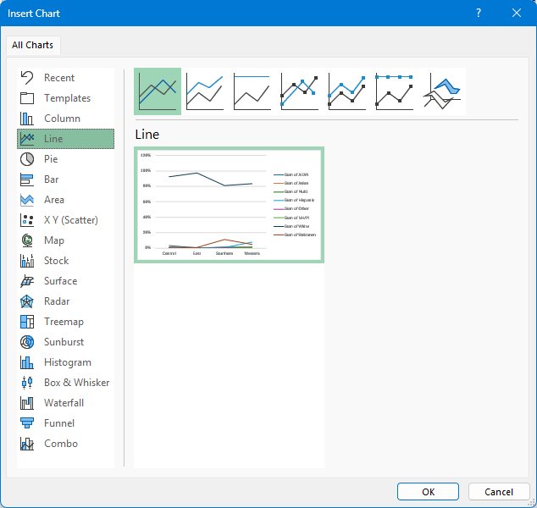
Select the style you think will best display the data.
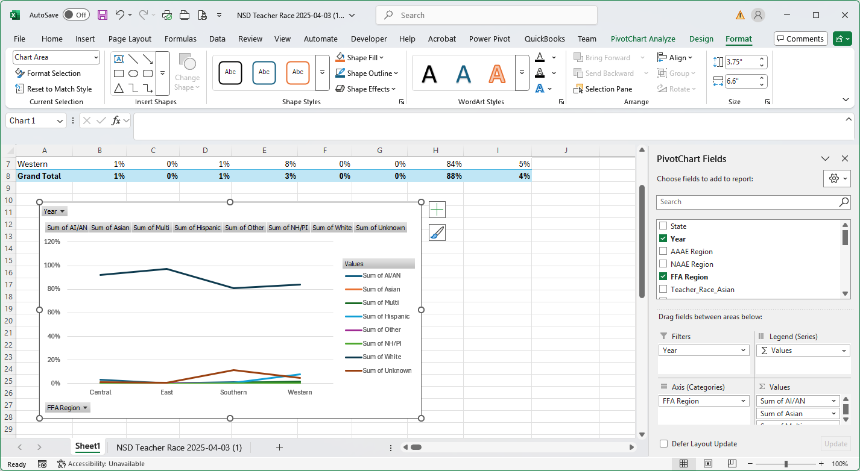
Changing the pivot table will change the chart. Hints for a finished looking chart:
- Hide the buttons by right clicking on one of the buttons and selecting Hide All Field Buttons.
- Add Axis Titles and a Chart Title
- Place the Legend at the Bottom
- Edit the Legend descriptions. To do this edit the column headings. Add a space to the end if you get an error.
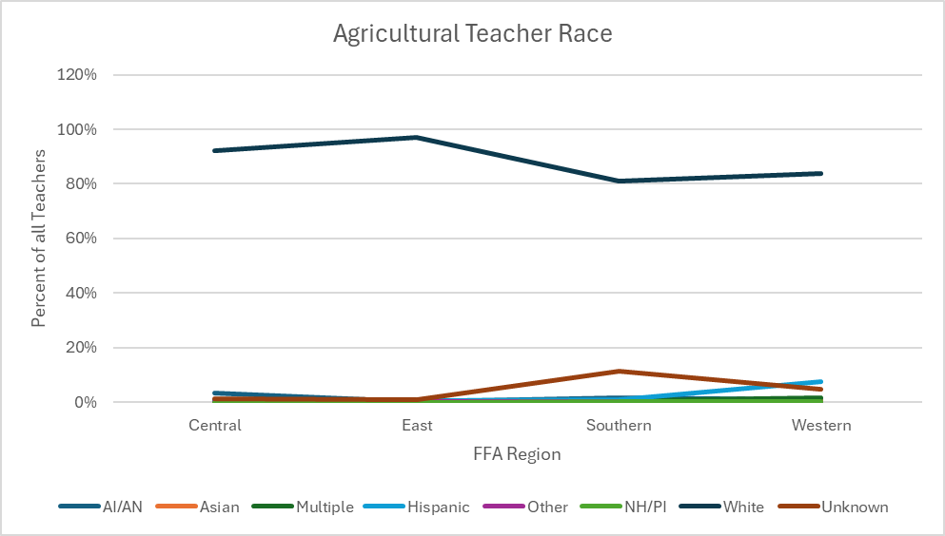

Filtering:
Data fields can be filtered by dragging a field into the filter box. For example, if you only want to display the FFA Central Region you can drag FFA Region to the filter box and then select only the Central Region. Note that filters can be applied to rows or columns directly. Filters allow selection of one or more items. Filters are useful when you wish to make multiple charts or analysis of the same data.
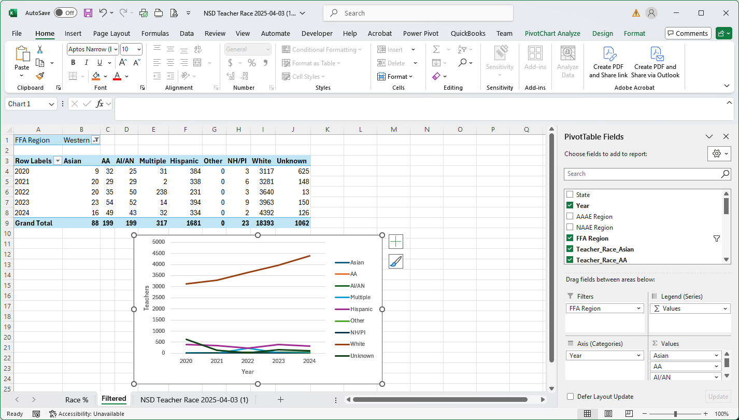
Filtered by Western Region (filter shown in A1).
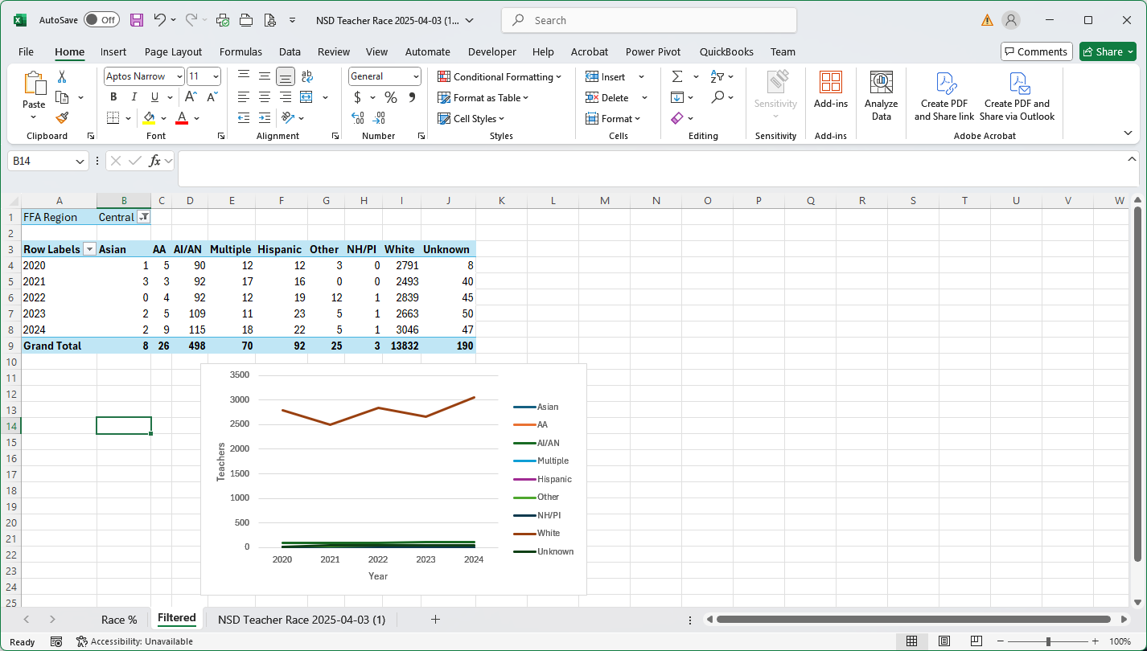
Filtered by Central Region

Additional Tips:
- To get a count of records simply select a alpha numeric field in the pivot table. Excel will automatically count the rows in the raw data. In this example you can use state.
- To perform calculations on pivot table data is often easier to extract the data for the table.
  - Select the data and copy.
  - Open a new sheet
  - Paste Values. Now you can easily do calculations and analysis on the calculated data.
  - Optionally create charts from the passed data.
- Label your sheets with descriptive labels for easier Access.
- Create multiple pivot tables for the same data set using different sheets.
- Charts should always have axis labels. A legend must be provided if the chart contains multiple data columns. The title may be omitted if in APA style it is described in the figure heading. Commonly you may wish to change the font size and color for use in a paper or poster. It is best to paste charts as graphics (see paste options) into Word or PowerPoint documents as this insures that they will not change.

