Quick Guide to the NSD Web Site
Enter the site using the URL: http://nsd.aaaeonline.org
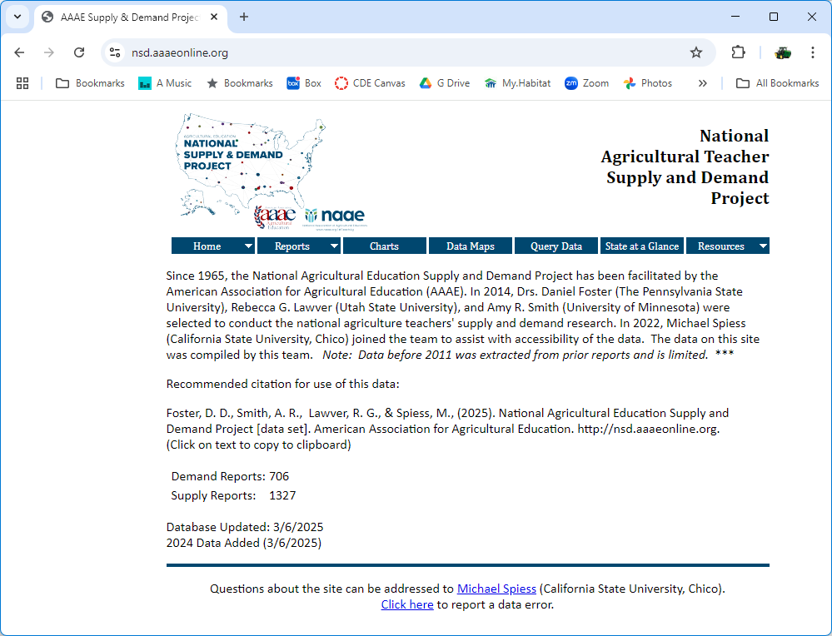
Choose from the menu: Resources Data and Report Descriptions. Review the descriptions of the various queries and data collected. If you intend to cite this data source in a paper you can cut and paste the citation provided.
Maps and Charts provide a simple way to explore the data sets.
To download data for analysis select Query Data from the menu.
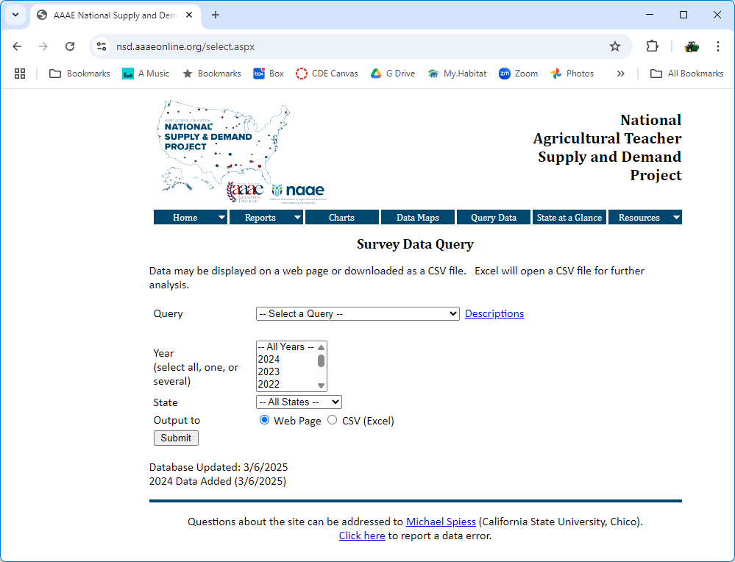
To explore the data choose a query. Optionally choose a year (or years) and a state. Use the default output to a web page. Note: The query description is displayed on the screen. The description is useful in understanding the data and its source.
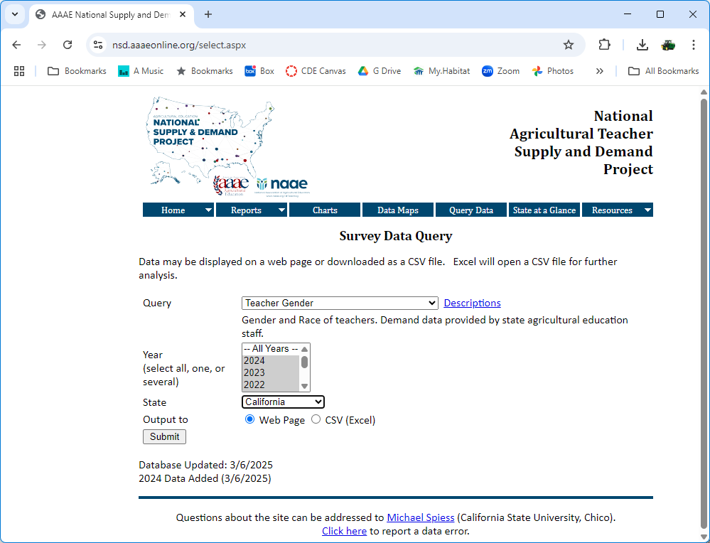
In this example the selection includes multiple years and a single state. The output of the query is shown below. Note: To select multiple years hold the CTRL key when clicking on the desired years.
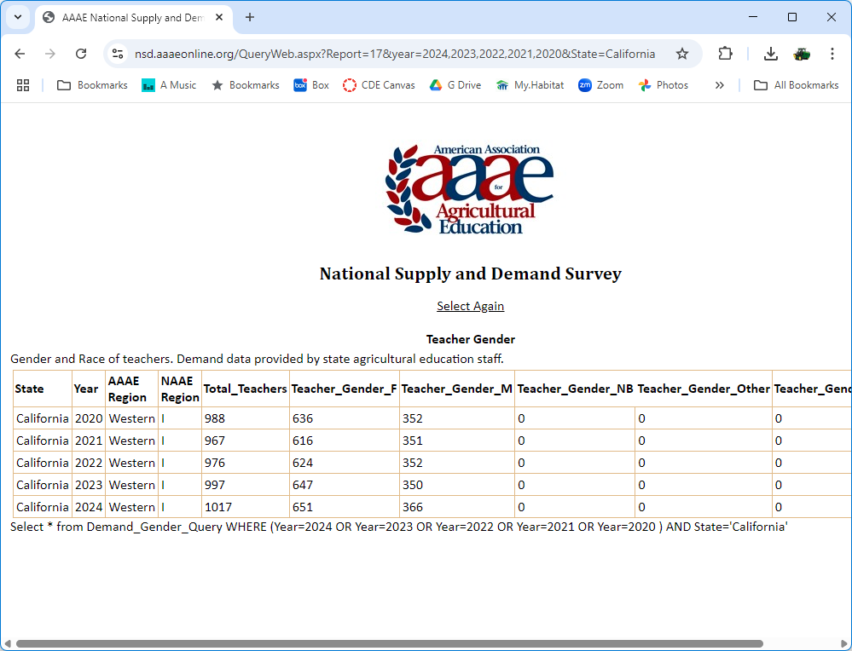
To save the data for analysis return to the query and select output to CSV. CSV files can be opened in Excel (or Google Sheets).
